UNIT 2
NETWORKS IN CLOUD COMPUTING

2.1. Introduction to Parallel and Distributed Computing:
Parallel Computing:
- Parallel computing is also called parallel processing.
- Parallel computing refers to the process of executing several processors an application or computation simultaneously.
- Each of them performs the computations assigned to them.
- In other words, in parallel computing, multiple calculations are performed simultaneously.
- The systems that support parallel computing can have a shared memory or distributed memory.
- In shared memory systems, all the processors share the memory.
- In distributed memory systems, memory is divided among the processors.
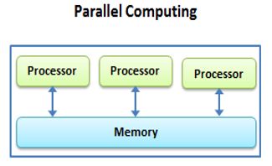
Advantages:
- As there are multiple processors working simultaneously, it increases the CPU utilization and improves the performance.
- Moreover, failure in one processor does not affect the functionality of other processors. Therefore, parallel computing provides reliability.
Disadvantages:
- On the other hand, increasing processors is costly.
- Furthermore, if one processor requires instructions of another, the processor might cause latency.

Distributed Computing:
- In distributed computing we have multiple autonomous computers which seems to the user as single system.
- In distributed systems there is no shared memory and computers communicate with each other through message passing.
- In distributed computing a single task is divided among different computers.
- A computer in the distributed system is a node while a collection of nodes is a cluster.
- They work together to achieve the common goal.
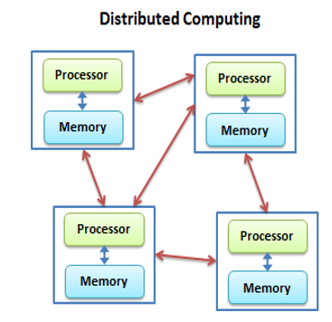

Advantages
- It allows scalability and makes it easier to share resources easily.
- It also helps to perform computation tasks efficiently.
Disadvantages:
- On the other hand, it is difficult to develop distributed systems.
- Moreover, there can be network issues.

2.2. Network Architecture for Cloud: Data Center Network and Cloud Network:
Data Center:
- Data centres are simply centralized locations where computing and networking equipment is concentrated for the purpose of collecting, storing, processing, distributing or allowing access to large amounts of data.
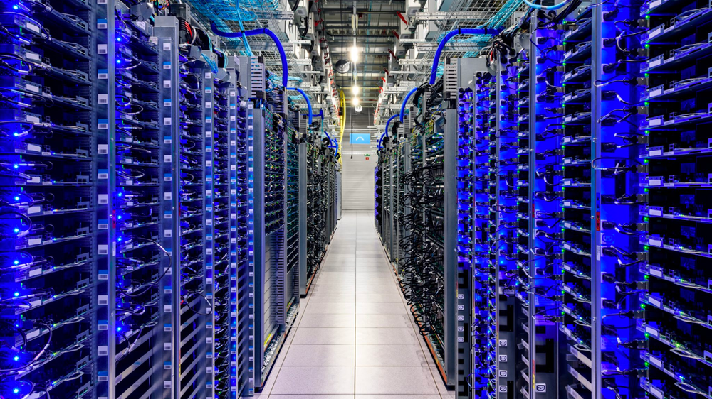
- A certain premise where an entire organization’s IT operations and equipment are centralized and, where it stores, analyses and distributes large amounts of data is known as a Data center.
- Earlier, the data processing needs were not too high but now-a-days those needs have grown exponentially. Data centres are now essential for daily operations and are important for business continuity.
- They are reliable to store enormous amounts because of their avant-garde security levels that keep the organization’s data safe at all times.
- The DC site, which is also known as a Server Farm, is connected to a communication network so that information can be accessed easily and remotely.
- There are thousands of very small powerful servers running in a data center which can be harboured in a room, a floor or an entire building.
Important components of a Data Center
- Power and Backup
- Cooling
- Network Operations.
- Safety ad Reliability
- Physical Security
- Redundancy & Redundant

Cloud Networking:
- Cloud networking is a type of IT infrastructure in which some or all of an organization’s network capabilities and resources are hosted in a public or Private cloud platform, managed in-house or by a service provider, and available on demand.
- Companies can either use on-premises cloud networking resources to build a private cloud network or use cloud-based networking resources in the public cloud, or a hybrid cloud combination of both.
- These network resources can include virtual routers, firewalls, and bandwidth and network management software, with other tools and functions available as required.

Benefits of cloud networking
- Most organizations have become a patchwork of on-premises technologies, public cloud services, legacy applications and systems, and emerging technologies — a complex situation that contributes to a weak security posture and results in inadequate governance, visibility, and manageability across fragmented networks.
- A Virtual Cloud Network is VMware’s vision of the future of networking.
- It is an architectural approach (not a product) built in software at global scale from edge-to-edge, that’s able to deliver consistent, pervasive connectivity and security for apps and data wherever they reside, independent of underlying physical infrastructure. Whether your workloads are on premises or in the cloud, the same network and security stack can be used to provide connectivity, security, and visibility.
- It is also the kind of next-generation networking service consumption technology that IT is increasingly adopting to provide the digital fabric that helps unify a hyper-distributed world.

2.3. Virtualization In Cloud Computing and Types
- Virtualization is a technique of how to separate a service from the underlying physical delivery of that service.
- It is the process of creating a virtual version of something like computer hardware.
- It was initially developed during the mainframe era.
- It involves using specialized software to create a virtual or software-created version of a computing resource rather than the actual version of the same resource.
- With the help of Virtualization, multiple operating systems and applications can run on same machine and its same hardware at the same time, increasing the utilization and flexibility of hardware.
- In other words, one of the main cost effective, hardware reducing, and energy saving techniques used by cloud providers is virtualization.
- Virtualization allows to share a single physical instance of a resource or an application among multiple customers and organizations at one time.
- It does this by assigning a logical name to a physical storage and providing a pointer to that physical resource on demand.
- The term virtualization is often synonymous with hardware virtualization, which plays a fundamental role in efficiently delivering Infrastructure-as-a-Service (IaaS) solutions for cloud computing.
- Moreover, virtualization technologies provide a virtual environment for not only executing applications but also for storage, memory, and networking.
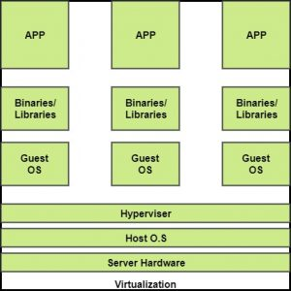

- The machine on which the virtual machine is going to be built is known as Host Machine and that virtual machine is referred as a Guest Machine.

BENEFITS OF VIRTUALIZATION
1. More flexible and efficient allocation of resources.
2. Enhance development productivity.
3. It lowers the cost of IT infrastructure.
4. Remote access and rapid scalability.
5. High availability and disaster recovery.
6. Pay peruse of the IT infrastructure on demand.
7. Enables running multiple operating systems.
Types of Virtualizations:
1.Application Virtualization.
2.Network Virtualization.
3.Desktop Virtualization.
4.Storage Virtualization.
5.Server Virtualization.
6.Data virtualization.
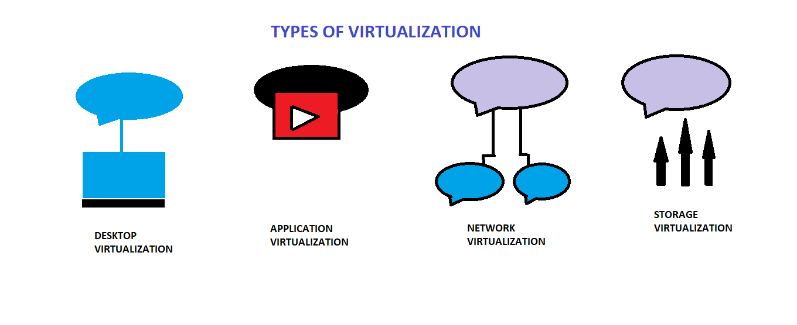
1. Application Virtualization:
- Application virtualization helps a user to have remote access of an application from a server. The server stores all personal information and other characteristics of the application but can still run on a local workstation through the internet. Example of this would be a user who needs to run two different versions of the same software. Technologies that use application virtualization are hosted applications and packaged applications.
2. Network Virtualization:
- The ability to run multiple virtual networks with each has a separate control and data plan. It co-exists together on top of one physical network. It can be managed by individual parties that potentially confidential to each other. Network virtualization provides a facility to create and provision virtual networks—logical switches, routers, firewalls, load balancer, Virtual Private Network (VPN), and workload security within days or even in weeks.
3. Desktop Virtualization:
- Desktop virtualization allows the users’ OS to be remotely stored on a server in the data centre. It allows the user to access their desktop virtually, from any location by a different machine. Users who want specific operating systems other than Windows Server will need to have a virtual desktop. Main benefits of desktop virtualization are user mobility, portability, easy management of software installation, updates, and patches.

4. Storage Virtualization:
- Storage virtualization is an array of servers that are managed by a virtual storage system. The servers aren’t aware of exactly where their data is stored, and instead function more like worker bees in a hive. It makes managing storage from multiple sources to be managed and utilized as a single repository. storage virtualization software maintains smooth operations, consistent performance and a continuous suite of advanced functions despite changes, break down and differences in the underlying equipment.
5. Server Virtualization:
- This is a kind of virtualization in which masking of server resources takes place. Here, the central-server (physical server) is divided into multiple different virtual servers by changing the identity number, processors. So, each system can operate its own operating systems in isolate manner. Where each sub-server knows the identity of the central server. It causes an increase in the performance and reduces the operating cost by the deployment of main server resources into a sub-server resource. It’s beneficial in virtual migration, reduce energy consumption, reduce infrastructural cost, etc.
6. Data virtualization:
- This is the kind of virtualization in which the data is collected from various sources and managed that at a single place without knowing more about the technical information like how data is collected, stored & formatted then arranged that data logically so that its virtual view can be accessed by its interested people and stakeholders, and users through the various cloud services remotely. Many big giant companies are providing their services like Oracle, IBM, At scale, Cdata, etc
2.4. Cloud Automation:
- Cloud automation enables IT teams and developers to create, modify, and tear down resources on the cloud automatically.
- One of the major promises of cloud computing was that services could be used on demand, if and when needed.
- But in reality, someone needs spin up those resources, test them, identify when they are no longer needed, and take them down, and this can represent a huge manual effort.
- Cloud automation is not built into the cloud; it requires expertise and the use of specialized tools.
- Cloud automation requires hard work, but it pays off when you get through the initial pain and gain the ability to perform complex tasks at the click of a button.

Benefits of Cloud Automation:
- Improved security and resilience—when sensitive tasks are automated, you do not need multiple IT people or developers logging into mission critical systems. The risk of human error, malicious insiders and account compromise is vastly reduced.
- Improved backup processes—organizations need to back up their system frequently, to guard against accidental erasure, configuration calamity, equipment failure or cyber-attack. Automating backups on the cloud, or backing up on-premise systems automatically to the cloud, dramatically improves an organization’s resilience to disaster.
- Improved governance—. Cloud automation lets you set up resources in a standardized, controlled manner, which also means you have much more control over infrastructure running across your organization.

2.5. Hybrid Cloud Networking:
- Hybrid cloud computing is an environment that creates flexibility by allowing a business to use both public and private networks for different uses.
- Advances in virtualization technology have made cloud computing more feasible, cost-efficient, and useful for an ever-expanding number of use cases.
Benefits of Hybrid Cloud Computing
- Agility is the primary benefit of hybrid cloud networking.
- When computing demands surge, companies can handle that overflow by safely scaling up their on-site infrastructure to a public cloud—without giving third parties access to all of the company’s data.
- Enterprises can protect business-critical applications and data behind more comprehensive security measures, while still using the flexible and cost-efficient computing power of the public cloud for less sensitive tasks and information, depending on their needs
Hybrid Cloud Platform:
- To function efficiently and usefully, a hybrid cloud’s various environments and the resources within those environments need to be accessible and manageable in a streamlined way.
- A hybrid cloud platform thus provides central management capabilities for accessing, organizing and utilizing the on-premises, private cloud and public cloud resources.
- Essentially the hybrid cloud platform creates one unified network architecture from all the disparate parts that make up a hybrid cloud.

2.6. Concept of Autonomic Computing:
- Autonomic computing is a self-managing computing model named after, and patterned on, the human body's autonomic nervous system.
- An autonomic computing system would control the functioning of computer applications and systems without input from the user, in the same way that the autonomic nervous system regulates body systems without conscious input from the individual.
- The goal of autonomic computing is to create systems that run themselves, capable of high-level functioning while keeping the system's complexity invisible to the user.

Need Of Autonomic Computing
- With the increase in the demand for computers, computer-related problems are also increasing. They are becoming more and more complex.
- The complexity has become so much that there is a spike in demand for skilled workers.
- This has fostered the need for autonomic computers that would do computing operations without the need for manual intervention.

Areas Of Autonomic Computing
There are four areas of Autonomic Computing as defined by IBM. These are as follows:
- Self-Configuration: The system must be able to configure itself automatically according to the changes in its environment.
- Self-Healing: IBM mentions that an autonomic system must have property by which it must be able to repair itself from errors and also route the functions away from trouble whenever they are encountered.
- Self-Optimization: According to IBM an autonomic system must be able to perform in an optimized manner and ensure that it follows an efficient algorithm for all computing operations.
- Self-Protection: the IBM States that an autonomic system must be able to perform detection, identification, and protection from the security and system attacks so that systems’ security and integrity remain intact.

Characteristics
- The Autonomic system knows itself. This means that it knows its components, specifications capacity, and the real-time status. It also has knowledge about its own, borrowed, and shared resources.
- It can configure itself again and again and run its setup automatically as and when required.
- It has the capability of optimizing itself by fine-tuning workflows.
- It can heal itself. This is a way of mentioning that it can recover from failures.
- It can protect itself by detecting and identifying various attacks on it.
- It can open itself. This means that it must not be a proprietary solution and must implement open standards.
- It can hide. This means that it has the ability to allow resource optimization, by hiding its complexity.
- An autonomic system according to IBM must be able to know or expect what kind of demand is going to arise for its resources to make it a transparent process for the users to see this information.

2.7. Open-Source Software in Data Centres:
Tools for running a Data Centres are described below:
1. DCImanager
- It is a platform for managing physical equipment: servers, switches, PDU, routers; and monitoring server and data center resources.
- It helps to optimize the use of computing power, enhance the efficiency of the IT department, and flexibly transform the infrastructure according to business tasks.

The main features of DCImanager are:
- DCIM with multi-vendor support and equipment inventory.
- Monitoring and notifications system.
- Remote access to servers.
- Managing switches, physical networks, VLAN.
- Server sales automation for hosting providers.
- Staff (or client) access to selected infrastructure nodes.

2. Opendcim
- Currently, it’s the one and the only free software in its class.
- It has an open source-code and designed to be an alternative to commercial DCIM solutions.
- Allows to keep inventory, draw a DC map, and monitor temperature and power consumption.
- On the other hand, it doesn’t support remote power-off, server rebooting, and OS installation functionality.
- Nevertheless, it is widely used in non-commercial organizations all around the globe.

3. NOC-PS
- A commercial system, designed for provisioning physical and virtual machines.
- Has a wide functionality for advanced preparation of equipment: OS and other software installation and setting up network configurations, there is WHMCS (Web Hosting Billing & Automation Platform) and Blesta (Billing and Client Management Platform) integrations.
- However, it won’t be your best choice if you need to have a Data Center map at hand and see the location of the rack.

4. EasyDCIM
- It is a paid software mainly oriented on server provisioning.
- Brings OS and other software installation features and facilitates DC navigation allowing to draw a scheme of racks.
- Meanwhile, the product itself doesn’t include IPs and DNS management, control over the switches.
- These and other features become available after additional modules installation, both free and paid (including WHMCS integration).

5. Ansible Tower
- It is a Enterprise-level computing infrastructure management tool from RedHat.
- The main idea of this solution was the possibility of a centralized deployment as for servers as for the different user devices.
- Ansible Tower can perform almost any possible program operation with integrated software and has an amazing statistic collecting module.
- On the dark side, we have a lack of integration with popular billing systems and pricing.

6. Puppet Enterprise
7. NetBox
8. RackTables
9. Device 42
10. CenterOS

